Research Result

Characteristic of Respondent
Data collection by researchers was carried out by distributing questionnaires to 130 employees at PT XYZ West Java. The results of distributing this questionnaire can inform the characteristics used in the research subject. The characteristics of the respondents presented in this study include gender, age, education level, and length of work. Analysis of the characteristics of respondents can be seen in the form of descriptive statistics in the form of charts.

Characteristic of Respondent by Gender
The characteristics of respondents based on gender are divided into two, namely male and female. The distribution of respondent characteristics based on gender can be seen in Figure 4.1:

Figure 1
Characteristic of Respondent by Gender
Source: Processed by the author

Based on the data above, it shows that as many as 81% or as many as 105 respondents were male, and the remaining 19% or as many as 25 respondents were female. The majority of respondents in the gender category are male, namely 81%, this is because the majority of questionnaires are distributed to employees of the PT XYZ West Java whose majority gender is male. According to Robbins (2015:9) there were no consistent male-female differences in problem-solving skills, analytical skills, competitive drive, motivation, sociability, or learning abilities.

Characteristic of Respondent by Age
The characteristics of respondents based on age are divided into four groups, namely the age group 20-30 years, 31-40 years, 41-50 years, and ≥ 51 years. The distribution of respondent characteristics by age can be seen in Figure 4.2 below:

Figure 2
Characteristic of Respondent by Age
Source: Processed by the author

Based on the data above shows that 18 respondents or 14% were 20-30 years old, 9 respondents or 7% aged 31-40 years, 24 respondents or 18% aged 41-50 years, and 79 respondents or 61% who were old. The majority of respondents were ≥ 51 years old, this is because the majority of the questionnaires were distributed to employees of PT XYZ in the West Java whose majority ≥ 51years old. According to Robbins (2015:28) as jobs age, they have fewer job alternatives as their skills become more specific to that type of job.

Characteristic of Respondent by Education
Characteristics of respondents based on the latest education level are divided into four groups, namely Diploma, Undergraduate, Postgraduate, and Doctoral Degree. The distribution of characteristics of respondents based on the latest education level can be seen in Figure 4.3:

Figure 3
Characteristic of Respondent by Education
Source: Processed by the author

Based on the data above, it shows that 56% or as many as 73 respondents had a Bachelor's level of education (S1), 5,1% or as many as 7 respondents whose education level was Postgraduate (S2), 39% or as many as 50 respondents whose education level was Diploma (D1-D3) and 0% or there isn't respondents whose education level is Doctoral (S3) The majority of respondents with a degree of education are Bachelor (S1), this is because the majority of questionnaires are distributed to employees of PT XYZ West Java whose majority education level is Bachelor (S1). According to Hartatik (2014:66) Education with its various programs has an important role in the process of obtaining and improving the quality of individual professional abilities and this will later appear in their performance, which in turn will guarantee increased work productivity.

Characteristic of Respondent by Length of Work
Characteristics of respondents based on the length of work are divided into four groups, namely <1 years, 1-5 years, 6-10 years, and >10 years. The distribution of characteristics of respondents based on the length of work can be seen in Figure 4.4:

Figure 4
Characteristic of Respondent by Length of Work
Source: Processed by the author

Based on the data above shows that 2 respondents or 2% were <1 years length of work, 15 respondents or 11% length of work, 4 respondents or 3% has 6-10 years length of work, and 109 respondents or 84% who were >10 years length of work. The majority of respondents were >10 years, this is because the majority of the questionnaires were distributed to employees of PT XYZ in the West Java whose majority has >10 years length of work. According to Robbins tenure is work experience, is seen as a good predictor of work productivity and the longer a person is in the job, the less likely they are to leave.

Normality Test
The normality of the data in this study was carried out by looking at the z value. The z value of this data can be seen from the critical value determined through the specified level of significance, namely 0.01 and the critical value is ± 2.58. In data processing with IBM Amos 24, the z value is seen from the critical ratio. The results of the normality test can be seen in the table below:
TABLE 1
NORMALITY TEST
Variable | min | max | skew | c.r. | kurtosis | c.r.
DEM7 | 2.000 | 5.000 | -.315 | -1.466 | -.336 | -.783
DEM5 | 2.000 | 5.000 | -.288 | -1.339 | -.958 | -2.228
DEM4 | 3.000 | 5.000 | -.328 | -1.525 | -.770 | -1.792
(continued)

TABLE 1 (continuance)
DEV9 | 3.000 | 5.000 | -.157 | -.729 | -.552 | -1.285
DEV8 | 2.000 | 5.000 | -.407 | -1.895 | .125 | .292
DEV7 | 2.000 | 5.000 | -.416 | -1.936 | .464 | 1.080
DEV5 | 2.000 | 5.000 | -.407 | -1.892 | -.263 | -.613
DEV4 | 2.000 | 5.000 | -.565 | -2.630 | -.240 | -.559
DIA10 | 2.000 | 5.000 | -.371 | -1.727 | -.286 | -.666
DIA5 | 2.000 | 5.000 | -.597 | -2.779 | .237 | .552
DEP11 | 2.000 | 5.000 | -.403 | -1.875 | -.088 | -.206
DEP9 | 2.000 | 5.000 | -.655 | -3.050 | -.010 | -.023
DEP8 | 2.000 | 5.000 | -.757 | -3.524 | .370 | .862
DEP2 | 2.000 | 5.000 | -.821 | -3.821 | .458 | 1.066
Multivariate |  |  |  |  | 78.604 | 21.171
Source: Processed by the author
In the result of normality output above, it appears that there is no critical ratio value that is above 2.58 or below - 2.58. For Kurtosis the highest value was -2.228 (KP2). Based on these results it can be stated that the normality assumption is fulfilled.

Research Result

First Order Confirmatory Factor Analysis
Researcher used the first order confirmatory factor analysis to test whether a construct has unidimensional or whether the indicators can confirm a construct or variable. To prove the indicator, researcher connecting the measure variable or in this research is the statement score with the latent variable or the four factor. The results of the first order confirmatory factor analysis in this study can be seen in table 4.2:
TABLE 2
OUTPUT FIRST ORDER CONFIRMATORY FACTOR ANALYSIS
Latent Variable | Measurable Variable | Output
 |  | Mediocre Fit Category
Deployment | DEP1, DEP2, DEP3, DEP4, DEP5, DEP6, DEP7, DEP8, DEP9, DEP10, DEP11, DEP12 | DEP2, DEP4, DEP8, DEP9, DEP10, DEP11, DEP12
(continued)

TABLE 2 (continuance)
Diagnosis | DIA1, DIA2, DIA3, DIA4, DIA5, DIA6, DIA7, DIA8, DIA9, DIA10 | DIA1, DIA5, DIA7, DIA8, DIA9, DIA10
Development | DEV1, DEV2, DEV3, DEV4, DEV5, DEV6, DEV7, DEV8, DEV9 | DEV2, DEV3, DEV4, DEV5, DEV6, DEV7, DEV8, DEV9
Demarcation | DEM1, DEM2, DEM3, DEM4, DEM5, DEM6, DEM7 | DEM1, DEM4, DEM5, DEM6, DEM7
Source: Processed by the author
- Deployment
There are twelve questions that become indicators of deployment factors. The twelve questions were tested on 130 respondents. From the results of the first order confirmatory analysis, it can be seen that the indicators that meet the rule of thumb with a factor loading value above 0.6 are only seven indicators. Meanwhile, the other five indicators have a factor loading value below 0.6 which means they do not meet the validity requirements for further analysis. From the results of this analysis, it can be seen that the dimensions of the deployment factor represented by indicators DEP2, DEP4, DEP8, DEP9, DEP10, DEP11, and DEP12.
- Diagnosis
There are ten questions that become indicators of diagnosis factors. The ten questions were tested on 130 respondents. From the results of the first order confirmatory analysis, it can be seen that the indicators that meet the rule of thumb with a factor loading value above 0.6 are only six indicators. Meanwhile, the other four indicators have a factor loading value below 0.6 which means they do not meet the validity requirements for further analysis. From the results of this analysis, it can be seen that the dimensions of the diagnosis factor represented by indicators DIA1, DIA5, DIA7, DIA8, DIA9, and DIA10.
- Development
There are nine questions that become indicators of diagnosis factors. The nine questions were tested on 130 respondents. From the results of the first order confirmatory analysis, it can be seen that the indicators that meet the rule of thumb with a factor loading value above 0.6 are only eight indicators. Meanwhile, one indicator has a factor loading value below 0.6 which means it does not meet the validity requirements for further analysis. From the results of this analysis, it can be seen that the dimensions of the development factor represented by indicators DEP2, DEP3, DEP4, DEP5, DEP6, DEP7, DEP8, and DEP9.
- Demarcation
There are seven questions that become indicators of demarcation factors. The seven questions were tested on 130 respondents. From the results of the first order confirmatory analysis, it can be seen that the indicators that meet the rule of thumb with a factor loading value above 0.6 are only five indicators. Meanwhile, the other two indicators have a factor loading value below 0.6 which means they do not meet the validity requirements for further analysis. From the results of this analysis, it can be seen that the dimensions of the demarcation factor represented by indicators DEM1, DEM4, DEM5, DEM6, and DEM7.
Estimation is done by analyzing the full-model too see the suitability of the model and the causality relationship built in the model being tested. In testing if the data was fit, researchers needs to look at the data fit indexes and if the fitness index failed to achieve, it must be reprocessed by releasing certain data one by one until its achieve the fitness index.
The following are the results of the full model estimation in this study:
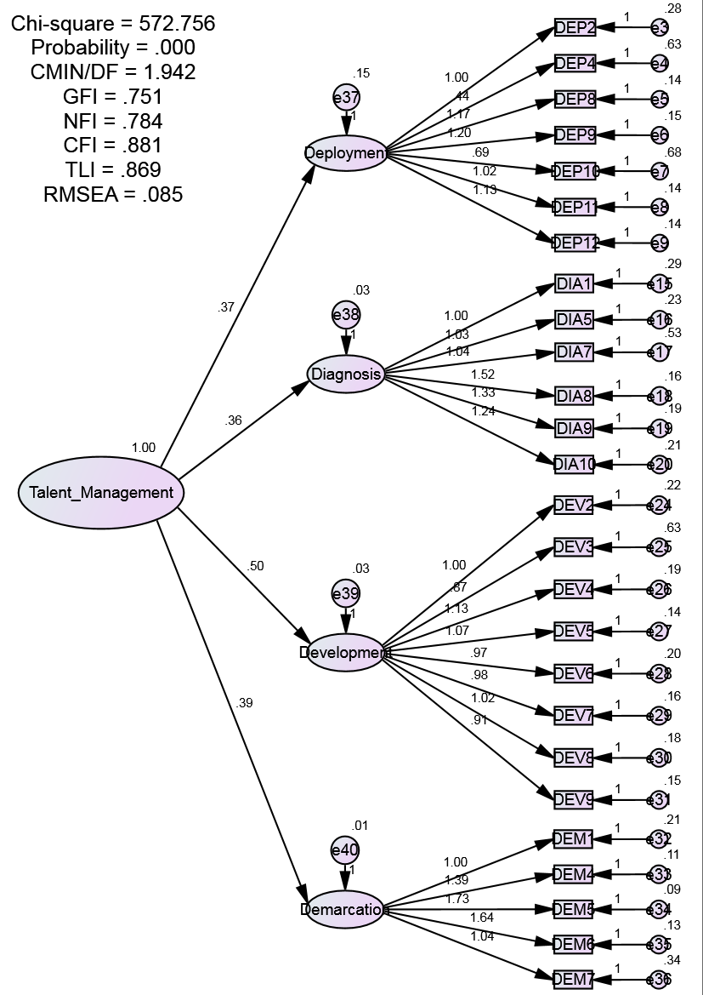
Figure 6
Second Order Analysis Model

Second Order Confirmatory Factor Analysis

Data Fit
Researcher used the second order confirmatory factor analysis to analyze the correlation between a large number of variable and to test whether the dimensions of a structure and estimated value can describe how much factor loading contained in the latent variable. To prove the variable, researcher connecting the measure variable or in this research is the statement score with the latent variable or the four factor and then connecting again with one factor as a variable in this research is talent management. The results of the second order confirmatory factor analysis in this study can be seen in figure 4.6:
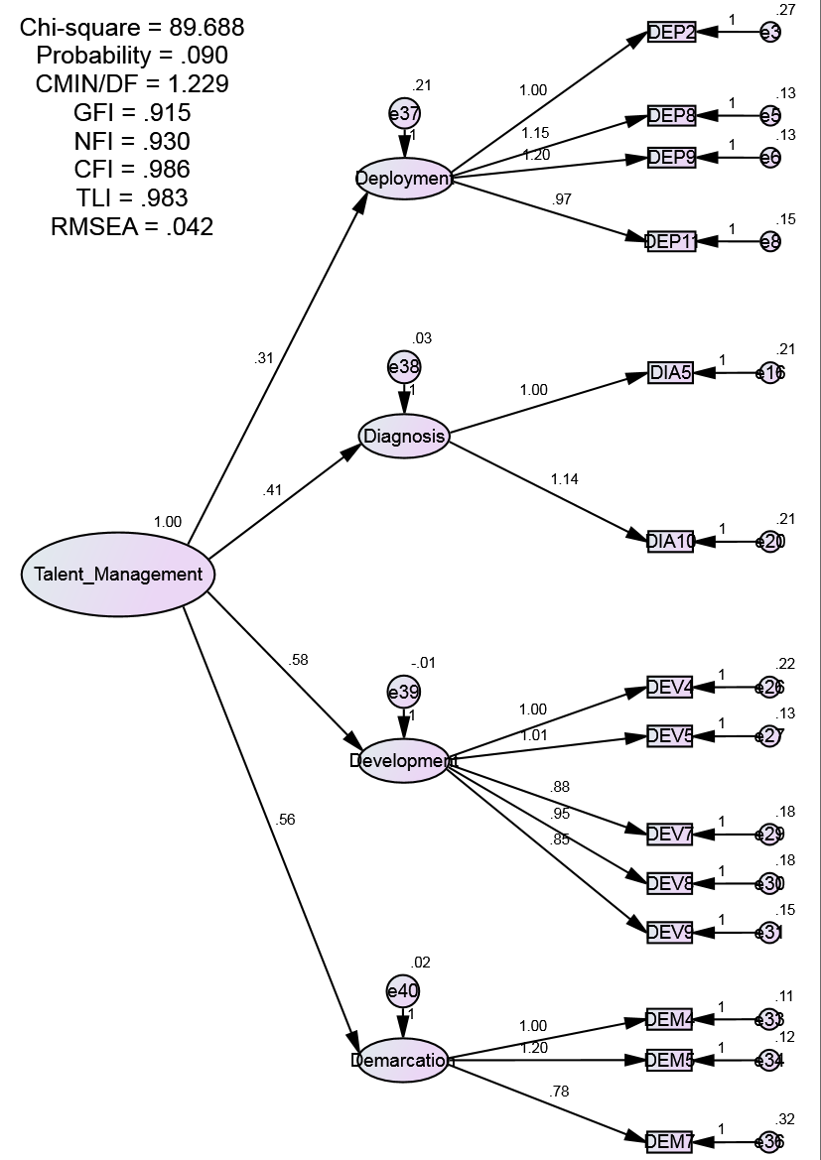
Figure 7
Second Order Analysis Model
Source: Processed by the author

Goodness of Fit Model
in testing the data fit researcher need to focus on reviewing the fitness indexes. If the fitness indexes failed to achieve the required level, then it must be reprocessed by releasing certain data one by one until fitness index achieve. Some of the important measurements in evaluating the goodness-of-fit criteria along with the cut-of value are as follows:
TABLE 3
GOODNESS OF FIT INDEX
Goodness of Fit Index | Cut Off Value | Estimation Result | Apposition
Chi-Square | ≥ 0.05 | 89.688 | Good
RMSEA | ≤ 0.08 | 0.042 | Good
GFI | ≥ 0.90 | 0.915 | Good
CMIN / DF | ≤ 2.00 | 1.229 | Good
TLI | ≥ 0.95 | 0.983 | Good
CFI | ≥ 0.95 | 0.986 | Good
Source: Processed by the author
The Chi-Square value is 89,688 with a probability value (p-value) of 0.090 (p> 0.05). The probability value meets the recommended standard value so that the model is suitable to be used as a tool to confirm the observed data. The RMSEA value is 0.042 below 0.08, the GFI value is 0.915 above 0.90, the AGFI value is 0. is above the recommended value of 0.90, then the CMIN / DF value is 1.229 is below 2. Furthermore, the TLI value = 0.983 and CFI = 0.986 it’s above 0.95. Based on the results of the analysis, the model was declared marginally feasible.
The initial results obtained there were many unfit statement from the four latent variables and the element that left from the four latent variable namely Deployment, Diagnosis, Development, and Demarcation, in the following statement elements:
TABLE 4
OUTPUT SECOND ORDER CONFIRMATORY FACTOR ANALYSIS
Latent Variable | Measurable Variable | Output
 |  | Mediocre Fit Category
Deployment | DEP2, DEP4, DEP8, DEP9, DEP10, DEP11, DEP12 | DEP2, DEP8, DEP9, DEP11
Diagnosis | DIA1, DIA5, DIA7, DIA8, DIA9, DIA10 | DIA5, DIA10
Development | DEV2, DEV3, DEV4, DEV5, DEV6, DEV7, DEV8, DEV9 | DEV4, DEV5, DEV7, DEV8, DEV9
Demarcation | DEM1, DEM4, DEM5, DEM6, DEM7 | DEM4, DEM5, DEM7
Source: Processed by the author
In the Table 4.1 above explains that after the data is processed and the variables are released one by one, the p-value is less than 0.05 and the RMSEA is greater than 0.05 to measure the sub-model tested is fit (the model fits the data). The final results of this SOCFA show that there are four latent variables and fourteen (14) statements (On The Deployment: DEP2, DEP8, DEP9, DEP11, Diagnosis: DIA5, DIA10, Development: DEV4, DEV5, DEV7, DEV8, DEV9 and Demarcation: DEM4, DEM5, DEM7 which shows RMSEA 0.042 and P-Value 0.090, this means that these four latent variables are included in the mediocre fit category (RMSEA 0.08-0.1)
TABLE 5
OUTPUT OF VARIABLE AND THE STATEMENT
Latent Variable | Statement Number | Statement
Deployment | DEP2 | Our screening assessment effectively identify five to ten outstanding candidates for each available position.
 | DEP8 | Our selection/promoting assessment measure leadership capability (i.e., skills and competencies that determine that the candidate can execute the requirements of the position).
 | DEP9 | Our selection/promoting assessment measure leadership alignment (i.e., how overwhelmingly connected and aligned the leader is to the vision/mission of the organization and how effectively they will get their team aligned).
 | DEP11 | We recognize that predicting future leadership performance is more complicated than just looking at a leader’s past performance.
Diagnosis | DIA5 | Our leaders and individual contributors are highly engaged.
 | DIA10 | We value discrepant information: the basis for uncovering where individuals are either over or underinflated, which then is the foundation for targeted coaching/development to unleash their performance.
Development | DEV4 | Our organizational structure is ideal given our vision and strategy as an organization.
 | DEV5 | Our leaders, individual contributors, and teams are well prepared for the inevitable changes that go with being part of a fast paced, innovative organization.
 | DEV7 | Our leaders and individual contributors create individual development plans (IDPs) based on a combination of subjective feedback from their manager and objective assessment result.
 | DEV8 | Learners are able to track their development progress/certify their knowledge and skills as they progress through development programs.
 | DEV9 | We are focused on ensuring that leadership development efforts produce an effective return on investment.
Demarcation | DEM4 | A players are clearly identified in our organization.
 | DEM5 | A player are accurately identified in our organization.
 | DEM7 | A players receive better rewards than B and C players.

Source: Processed by the author

Result Of Descriptive Analysis
According to the data processed and confirmatory analysis, there are several latent variables and some statements in the latent variables that are left, namely the latent variable Deployment: DEP2, DEP8, DEP9, DEP11, Diagnosis: DIA5, DIA10, Development: DEV4, DEV5, DEV7, DEV8, DEV9 and Demarcation: DEM4, DEM5, DEM7. These variables use a questionnaire that given 130 respondents of employees of the PT XYZ West Java with five alternative answers, namely: Strongly Agree, Agree, Neutral, Disagree, and Strongly Disagree.

Result Of Descriptive Analysis Of Variable Deployment
The variable Deployment has four remaining statement items which are presented in this research questionnaire, and the four statement items are declared feasible. Respondents' opinions regarding the Deployment variable are presented in Table 4.3 below.
TABLE 6
PERCENTAGE OF DEPLOYMENT VARIABLE
Item | Statement | SA | AN | N | D | SD | Total Score | % Category
DEP2 | Our screening assessment effectively identify five to ten outstanding candidates for each available position. | 51 | 61 | 14 | 4 | 0 | 549 | 84,46%
DEP8 | Our selection/promoting assessment measure leadership capability (i.e., skills and competencies that determine that the candidate can execute the requirements of the position). | 51 | 62 | 14 | 3 | 0 | 551 | 84,77%

DEP9 | Our selection/promoting assessment measure leadership alignment (i.e., how overwhelmingly connected and aligned the leader is to the vision/mission of the organization and how effectively they will get their team aligned). | 49 | 60 | 18 | 3 | 0 | 545 | 83,85%
DEP11 | We recognize that predicting future leadership performance is more complicated than just looking at a leader’s past performance. | 43 | 71 | 15 | 1 | 0 | 546 | 84,00%
Average Score |  |  |  |  |  |  |  | 547,75
Average Percentage DEP |  |  |  |  |  |  |  | 84,27%

Information:
Total score = (number of SS x measurement scale) + (number of S x measurement
scale) + Total TS x measurement scale) + (Number of STS x measurement scale)
% category = Total score: Total Max
Total Max = Number of samples x 5 = 130 x 5 = 650
Based on the results of the processing carried out which is presented in table 4.4 above, it can be seen that the average score for the determining factors for talent management Deployment, is 547.75. The sum of the scores is entered into a continuum line whose measurement is determined in the following manner:
Percentage of Score = (average score: ideal score) x 100%
= (547,75 : 650) x 100% = 84.3%
84,3%

VL
20%
36%
52%
68%
84%%
100%
L
M
H
VH

Figure 8
Position of Deployment Variable in Continuum Line

Source: Processed by the author
Criteria Score
VL = Very Low
L = Low
M = Moderate
H = High
VH = Very High
In Table 4.3, it can be described as follows:
- Our screening assessment effectively identify five to ten outstanding candidates for each available position.
Good talent management is the one that can effectively identify five to ten outstanding candidates trough assessment. The results of data processing show that employee assessment can effectively identify five to ten outstanding candidates at PT XYZ West Java, which has a percentage value of 84.46%. This means that PT XYZ West Java can determine that the candidate can execute the requirements of the position.
- Our selection/promoting assessment measure leadership capability (i.e., skills and competencies that determine that the candidate can execute the requirements of the position).
Good talent management is the one that can measure leadership capability of employee trough assessment. The results of data processing show that employee assessment can measure leadership capability of employee PT XYZ West Java, which has a percentage value of 84.77%. This means that apart from having a good score, employees PT XYZ West Java must also have leadership capability to be promoted.
- Our selection/promoting assessment measure leadership alignment (i.e., how overwhelmingly connected and aligned the leader is to the vision/mission of the organization and how effectively they will get their team aligned).
Good talent management is the one that can measure leadership alignment with company trough assessment. The results of data processing show that employee assessment can measure leadership alignment of employee PT XYZ West Java, which has a percentage value of 83.85%. This means that apart from having a good score and have leadership capability, employees PT XYZ West Java must also have connected and aligned to the vision/mission of the organization so employee make their best performance.
- We recognize that predicting future leadership performance is more complicated than just looking at a leader’s past performance.
Good talent management is the one that can predict future leadership performance through assessment. The results of data processing show that predicting future leadership performance is more complicated than just looking at a leader’s past performance, which has a percentage value of 84.00%. PT XYZ West Java need to look through their assessment, this means that assessment can predict future leadership performance from having a good score, have leadership capability, and aligned to the vision/mission of the organization.

Result Of Descriptive Analysis Of Variable Diagnosis
The variable Diagnosis has two remaining statement items which are presented in this research questionnaire, and the two statement items are declared feasible. Respondents' opinions regarding the Diagnosis variable are presented in Table 4.3 below:
TABLE 7
PERCENTAGE OF DIAGNOSIS VARIABLE
Item | Statement | SA | A | N | D | SD | Total Score |  | % Category
DIA5 | Our leaders and individual contributors are highly engaged. | 54 | 66 | 9 | 1 | 0 | 563 |  | 86,62%
DIA10 | We value discrepant information: the basis for uncovering where individuals are either over or underinflated, which then is the foundation for targeted coaching/development to unleash their performance. | 42 | 69 | 18 | 1 | 0 | 542 |  | 83,38%
Average Score |  |  |  |  |  |  |  |  | 552,5
Average Percentage DIA |  |  |  |  |  |  |  | 85%

Information:
Total score = (number of SS x measurement scale) + (number of S x measurement
scale) + Total TS x measurement scale) + (Number of STS x measurement scale)
% category = Total score: Total Max
Total Max = Number of samples x 5 = 130 x 5 = 650

Based on the results of the processing carried out which is presented in table 4.4 above, it can be seen that the average score for the determining factors for talent management Diagnosis, is 552,5. The sum of the scores is entered into a continuum line whose measurement is determined in the following manner:
Percentage of Score = (average score: ideal score) x 100%
= (552,5 : 650) x 100% = 85%
85%

VL
20%
36%
52%
68%
84%%
100%
L
M
H
VH

Figure 9
Position of Diagnosis Variable in Continuum Line

Source: Processed by the author
Criteria Score
VL = Very Low
L = Low
M = Moderate
H = High
VH = Very High
In Table 4.4, it can be described as follows:
- Our leaders and individual contributors are highly engaged.
A company that has Good talent management is A company that leaders and individual contributors are highly engaged, The results of data processing show that leaders and individual contributors of PT XYZ West Java are highly engaged, which has a percentage value of 86.62%. This means that leaders and individual contributors of PT XYZ West Java will do their best for the organization because leaders and individual contributor really engage with the organization and they feel part of the company.
- We value discrepant information: the basis for uncovering where individuals are either over or underinflated, which then is the foundation for targeted coaching/development to unleash their performance.
A company that has Good talent management is A company that appreciates discrepant information, The results of data processing show that PT XYZ West Java appreciate discrepant information, which has a percentage value of 83.38%. This means that PT XYZ West Java use discrepant information for uncovering where individuals are either over or underinflated, that can be used as a foundation for targeted coaching/development to unleash their performance.

Result of Descriptive Analysis Of Variable Development
The variable Development has five remaining statement items which are presented in this research questionnaire, and the five statement items are declared feasible. Respondents' opinions regarding the Development variable are presented in Table 4.3 below:
TABLE 8
PERCENTAGE OF DEVELOPMENT VARIABLE
Item | Statement | SA | A | N | D | SD | Total Score | % Category
DEV4 | Our organizational structure is ideal given our vision and strategy as an organization. | 49 | 60 | 19 | 2 | 0 | 546 | 84%
DEV5 | Our leaders, individual contributors, and teams are well prepared for the inevitable changes that go with being part of a fast paced, innovative organization. | 44 | 68 | 17 | 1 | 0 | 545 | 83,84%
DEV7 | Our leaders and individual contributors create individual development plans (IDPs) based on a combination of subjective feedback from their manager and objective assessment result. | 32 | 79 | 17 | 2 | 0 | 531 | 81,69%
DEV8 | Learners are able to track their development progress/certify their knowledge and skills as they progress through development programs. | 35 | 74 | 19 | 2 | 0 | 532 | 81,84
DEV9 | We are focused on ensuring that leadership development efforts produce an effective return on investment. | 40 | 75 | 15 | 0 | 0 | 545 | 83,84%
Average Score |  |  |  |  |  |  |  | 539,8
Average Percentage DEV |  |  |  |  |  |  |  | 83,042%

Information:
Total score = (number of SS x measurement scale) + (number of S x measurement
scale) + Total TS x measurement scale) + (Number of STS x measurement scale)
% category = Total score: Total Max
Total Max = Number of samples x 5 = 130 x 5 = 650
Based on the results of the processing carried out which is presented in table 4.4 above, it can be seen that the average score for the determining factors for talent management Diagnosis, is 552,5. The sum of the scores is entered into a continuum line whose measurement is determined in the following manner:
Percentage of Score = (average score: ideal score) x 100%
= (539,8 : 650) x 100% = 83,042%
83,04%

VL
20%
36%
52%
68%
84%%
100%
L
M
H
VH

Figure 10
Position of Development Variable in Continuum Line

Source: Processed by the author

Criteria Score
VL = Very Low
L = Low
M = Moderate
H = High
VH = Very High
In Table 4.4, it can be described as follows:
- Our organizational structure is ideal given our vision and strategy as an organization.
The results of data processing show that organizational structure of PT XYZ West Java is ideal given our vision and strategy as an organization, which has a percentage value of 86.62%, one of the example is when there’s a clearly defined roles and responsibilities.
- Our leaders, individual contributors, and teams are well prepared for the inevitable changes that go with being part of a fast paced, innovative organization.
Good talent management is the one that capable of inevitable changes The results of data processing show that leaders, individual contributors, and teams of PT XYZ West Java always hold a meeting every month to analyze their business planning as a result their well prepared for the inevitable changes that go with being part of a fast-paced, which has a percentage value of 83.84%.
- Our leaders and individual contributors create individual development plans (IDPs) based on a combination of subjective feedback from their manager and objective assessment result.
Good talent management is the one that creates individual development plans (IDPs) The results of data processing show that leaders and individual contributors of PT XYZ West Java are created their own individual development plans (IDPs) based on a combination of subjective feedback from their manager and objective assessment it can’t be proven because IDP is indivual but based on the percentage value of 81.69%. it can be conclude that leaders and individual contributors of PT XYZ West Java organizational have a short term and long term goals that they want to achieve.
- Learners are able to track their development progress/certify their knowledge and skills as they progress through development programs.
Good talent management is the one that transparency with their employee development progress The results of data processing show that PT XYZ West Java are transparency with their employee regarding their own development progress every employee can access through assessment center Indonesia which has a percentage value of 81.69%.
- We are focused on ensuring that leadership development efforts produce an effective return on investment.
Good talent management is the one that focused on ensuring that leadership development efforts produce an effective return The results of data processing show that PT XYZ West Java development program produce an effective return and every which has a percentage value of 83.84%.
This means that development programs of PT XYZ West Java are in line with what employee require as a result of effective return on investment .

Result Of Descriptive Analysis Of Variables Demarcation
The variable Demarcation has three remaining statement items which are presented in this research questionnaire, and the three statement items are declared feasible. Respondents' opinions regarding the Demarcation variable are presented in Table 4.3 below:
TABLE 9
PERCENTAGE OF DEMARCATION VARIABLE
Item | Statement | SA | A | N | D | SD | Total Score | % Category
DEM4 | A players are clearly identified in our organization. | 49 | 65 | 16 | 0 | 0 | 553 | 85,07%
DEM5 | A player are accurately identified in our organization. | 45 | 55 | 29 | 1 | 0 | 534 | 82,15%
DEM7 | A players receive better rewards than B and C players. | 35 | 68 | 25 | 2 | 0 | 526 | 80,92%
Average Score |  |  |  |  |  |  |  | 537,7
Average Percentage DEM |  |  |  |  |  |  |  | 82,71%
Source: Processed by the author
Information:
Total score = (number of SS x measurement scale) + (number of S x measurement
scale) + Total TS x measurement scale) + (Number of STS x measurement scale)
% category = Total score: Total Max
Total Max = Number of samples x 5 = 130 x 5 = 650
Based on the results of the processing carried out which is presented in table 4.4 above, it can be seen that the average score for the determining factors for talent management Diagnosis, is 552,5.
The sum of the scores is entered into a continuum line whose measurement is determined in the following manner:
Percentage of Score = (average score: ideal score) x 100%
= (537,7% : 650) x 100% = 82,71%
82,71%
VL
20%
36%
52%
68%
84%%
100%
L
M
H
VH

Figure 11
Position of Deployment Variable in Continuum Line

Source: Processed by the author
Criteria Score
VL = Very Low
L = Low
M = Moderate
H = High
VH = Very High

In Table 4.4, it can be described as follows:
- A players are clearly identified in our organization.
Good talent management is the one that classified their employee based on their talent, the results of data processing show that PT XYZ West Java classified their employee based on their talent which has a percentage value of 85.07%. The A players in XYZ it’s called talent.
- A player are accurately identified in our organization.
Good talent management is the one that accurately classified their employee based on their talent, the results of data processing show that PT XYZ West Java accurately classified their employee based on their talent which has a percentage value of 82.15%. The A players in PT XYZ called Talent.
- A players receive better rewards than B and C players.
Good talent management is the one that gives their employee bonus/reward regarding with their performance the results of data processing show that PT XYZ West Java gives their employee bonus/reward regarding with their performance which has a percentage value of 80.92%, in XYZ their bonus based on their positions.

Result of Data Processing

Result of The First Statement
The first research question, namely "Can the four factor form The Talent Management Practice at PT XYZ West Java?" answered by the results of AMOS data processing with the second order confirmatory analysis measurement method indicated by the RMSEA, P-Value, GFI and the factor loading of each latent variable that is fit.
In testing if the data was fit, the p value (p-value) must be greater than 0.05 and the RMSEA value is smaller than 0.08 (better less than 0.05). in this case, it must be reprocessed by releasing certain data one by one after the data is processed and the variables are released one by one. So that in the end, the results of this test produce fit data, indicated the RMSEA value of 0.042 (mediocre fit) and GFI of 0.915, all of the four latent variables can form talent management at PT XYZ West Java.
The second order confirmatory factor used to identify the estimated value that can describe how much factor loading contained in the latent variable in this research there are four latent variable namely, Development which is the highest factor loading with the value of 0.58 which means that Development has the major influence to the health of talent management; then Demarcation also has major influence to the health of talent management as indicated by factor loading with the value of 0.56; Diagnosis also contributed to the health of talent management as indicated by factor loading with the value of 0.41, and for Deployment it also contributes to the health of talent management that indicated by factor loading with the value of 0.31.

Result of The Second Statement
The second research question, namely "How the talent management at PT XYZ West Java according to the four factors?" this question answered by the results of the calculation of descriptive analysis related to respondents' perceptions of the four factors for talent management.
Answering the second research question, the results of the descriptive analysis showed that it was included in the very high category with a percentage value of 84.013%. This shows that talent management at PT XYZ West Java has been carried out well with the four determining factors, namely Deployment, Diagnosis, Development, and Demarcation.
Deployment variable which consists of four fit statements, namely DEP2, DEP8, DEP9, and DEP11 which considers as very high category with an average percentage value of 84.3%. This shows that the talents at PT XYZ West Java feel that the Deployment in the company is very useful to support talent management practices.
The highest percentage value for the Deployment variable is in the DEP8 statement, which is 84.77% and is included in the very high category. This means that the assessment carried out can measure the leadership capability of employees, with this all talents who will be promoting must have leadership capability. The lowest percentage value for the Deployment variable is in the DEP9 statement, which is 83.85%. Although it is lower than the other three sub-variables, this amount is still in the high category. This shows that Deployment is not an obstacle in talent management practice at PT XYZ West Java.
The diagnosis variable consists of two fit statements, namely DIA5 and DIA10 which include into the very high category with an average percentage value of 85%. This shows that employees at PT XYZ West Java feel that the diagnosis at PT XYZ West Java is useful for supporting talent management practices.
The highest percentage value in this variable is the DIA5 statement, which has value of 86.62% and its included in the very high category. This means that leaders and individual contributors are highly engaged with the organization that makes them do their best at work. The lowest percentage value on the Diagnosis variable is in the DIA10 statement, which is 83.38%. Even though it is lower than DIA5, it is still in the high category. This shows that Diagnosis is not an obstacle in talent management practice at PT XYZ West Java.
The development variable consists of five fit statements, namely DEV4, DEV5, DEV7, DEV8, and DEV9 which include into the high category with an average percentage value of 83.042%. This shows that employees at PT XYZ West Java feel that the development at PT XYZ West Java is useful for supporting talent management practices.
The highest percentage value in this variable is the DEV4 statement, which has value of 84% and its included in the high category. This means that Structure Organization of PT XYZ in line with their vision and strategy so each employee contributes to the success of the company. The lowest percentage value on the Development variable is the DEV7 statement, which has value of 81.69%. Even though it is lower than DEV4, it is still in the high category. This shows that Diagnosis is not an obstacle in talent management practice at PT XYZ West Java.
The demarcation variable consists of three fit statements, namely DEM4, DEM5, and DEM7 which include into the high category with an average percentage value of 82.71%. This shows that employees at PT XYZ West Java feel that the demarcation at PT XYZ West Java is useful for supporting talent management practices.
The highest percentage value in this variable is the DEM4 statement, which has value of 85.07% and its included in the very high category. This means that A players are clearly identified in PT XYZ West Java. The lowest percentage value on the Demarcation variable is the DEM7 statement, which has value of 80.92%. Even though it is lower than DEM4, it is still in the high category. This shows that Diagnosis is not an obstacle in talent management practice at PT XYZ West Java.

