Lampiran 1. Hasil Penelitian
- Karakteristik Pofil Responden
Tabel 1.1
Hasil Uji Deskripsi Responden Berdasarkan Jenis Kelamin
 |  | Frequency | Percent | Valid Percent | Cumulative Percent
Valid | laki laki | 22 | 66,7 | 66,7 | 66,7
 | perempuan | 11 | 33,3 | 33,3 | 100,0
 | Total | 33 | 100,0 | 100,0
Sumber: Data primer yang diolah
Tabel 1.2
Hasil Uji Deskripsi Responden Berdasarkan Usia

 |  | Frequency | Percent | Valid Percent | Cumulative Percent
Valid | <30 | 2 | 6,1 | 6,1 | 6,1
 | 31-40 | 12 | 36,4 | 36,4 | 42,4
 | >41 | 19 | 57,6 | 57,6 | 100,0
 | Total | 33 | 100,0 | 100,0
Sumber: Data primer yang diolah
Tabel 1.3
Hasil Uji Deskripsi Responden Berdasarkan Pendidikan Terakhir
 |  | Frequency | Percent | Valid Percent | Cumulative Percent
Valid | D3 | 1 | 3,0 | 3,0 | 3,0
 | S1 | 16 | 48,5 | 48,5 | 51,5
 | S2 | 14 | 42,4 | 42,4 | 93,9
 | Lainnya | 2 | 6,1 | 6,1 | 100,0
 | Total | 33 | 100,0 | 100,0
Sumber: Data primer yang diolah
Tabel 1.4
Hasil Uji Deskripsi Responden Berdasarkan Pengalaman Kerja
 |  | Frequency | Percent | Valid Percent | Cumulative Percent
Valid | <5 | 20 | 60,6 | 60,6 | 60,6
 | 6-10 | 11 | 33,3 | 33,3 | 93,9
 | >11 | 2 | 6,1 | 6,1 | 100,0
 | Total | 33 | 100,0 | 100,0
Sumber: Data primer yang diolah

Tabel 1.5
Hasil Uji Deskriptif Responden Berdasarkan Jenis Perusahaan
 |  | Frequency | Percent | Valid Percent | Cumulative Percent
Valid | Dagang | 3 | 9,1 | 9,1 | 9,1
 | Jasa | 18 | 54,5 | 54,5 | 63,6
 | Manufaktur | 4 | 12,1 | 12,1 | 75,8
 | Pemerintahan | 7 | 21,2 | 21,2 | 97,0
 | Lainnya | 1 | 3,0 | 3,0 | 100,0
 | Total | 33 | 100,0 | 100,0
Sumber: Data primer yang diolah

- Hasil Uji Instrumen Penelitian

Hasil Uji Statistik Desktriptif
Tabel 2.1
Hasil Uji Statistik Deskriptif

 | N | Minimum | Maximum | Mean | Std. Deviation
INTENSI | 33 | 3,00 | 9,00 | 4,4242 | 1,47966
SIKAP | 33 | 5,00 | 15,00 | 8,2727 | 2,82038
NORMA | 33 | 5,00 | 19,00 | 8,3030 | 3,25466
PERSEPSIAN | 33 | 5,00 | 21,00 | 13,3333 | 5,09084
SQ | 33 | 39,00 | 91,00 | 53,6061 | 8,54012
Valid N (listwise) | 33
Sumber: Data primer yang diolah

Hasil Uji Kualitas Data
Tabel 2.2
Hasil Uji Reabilitas
Variabel | Cronbach Alpha | Keterangan
Intensi Perilaku | 0,801 | Reliabel
Sikap dalam Berperilaku | 0,791 | Reliabel
Norma-norma Subyektif | 0,862 | Reliabel
Kendali Perilaku Persepsi | 0,819 | Reliabel
Spiritual Quotient | 0,927 | Reliabel
Sumber: Data primer yang diolah

Tabel 2.3
Hasil Uji Validitas Variabel Intensi Perilaku
Nomor butir pertanyaan | Pearson Correlation | Sig (2-Tailed) | Keterangan
1 | 0,778 | 0,00 | Valid
2 | 0,904 | 0,00 | Valid
3 | 0,861 | 0,00 | Valid
Sumber: Data primer yang diolah
Tabel 2.4
Hasil Uji Validitas Variabel Sikap dalam Berperilaku
Nomor butir pertanyaan | Pearson Correlation | Sig (2-Tailed) | Keterangan
4 | 0,667 | 0,00 | Valid
5 | 0,719 | 0,00 | Valid
6 | 0,755 | 0,00 | Valid
7 | 0,755 | 0,00 | Valid
8 | 0,887 | 0,00 | Valid
Sumber: Data primer yang diolah
Tabel 2.5
Hasil Uji Validitas Variabel Norma-norma Subyektif
Nomor butir pertanyaan | Pearson Correlation | Sig (2-Tailed) | Keterangan
9 | 0,894 | 0,00 | Valid
10 | 0,902 | 0,00 | Valid
11 | 0,902 | 0,00 | Valid
12 | 0,692 | 0,00 | Valid
13 | 0,574 | 0,00 | Valid
Sumber: Data primer yang diolah
Tabel 2.6
Hasil Uji Validitas Variabel Kendali Perilaku Persepsi
Nomor butir pertanyaan | Pearson Correlation | Sig (2-Tailed) | Keterangan
14 | 0,775 | 0,00 | Valid
15 | 0,866 | 0,00 | Valid
16 | 0,905 | 0,00 | Valid
17 | 0,810 | 0,00 | Valid
18 | 0,656 | 0,00 | Valid
Sumber: Data Primer yang diolah
Tabel 2.7
Hasil Uji Validitas Variabel Spiritual Quotient
Nomor butir pertanyaan | Pearson Correlation | Sig (2-Tailed) | Keterangan
19 | 0,826 | 0,00 | Valid
20 | 0,651 | 0,00 | Valid
21 | 0,754 | 0,00 | Valid
22 | 0,779 | 0,00 | Valid
23 | 0,860 | 0,00 | Valid
24 | 0,779 | 0,00 | Valid
25 | 0,752 | 0,00 | Valid
26 | 0,690 | 0,00 | Valid
27 | 0,726 | 0,00 | Valid
28 | 0,626 | 0,00 | Valid
29 | 0,799 | 0,00 | Valid
30 | 0,752 | 0,00 | Valid
Sumber: Data primer yang diolah

- Hasil Uji Asumsi Klasik
Tabel 3.1
Hasil Uji Multikolonieritas
Model |  | Collinearity Statistics
 |  | Tolerance | VIF
1 | SIKAP | ,328 | 3,045
 | NORMA | ,316 | 3,165
 | Jenis Kelamin | ,784 | 1,275
 | SQ | ,961 | 1,041
a. Dependent Variable: INTENSI
Gambar 3.2
Hasil Uji Heteroskedastisitas
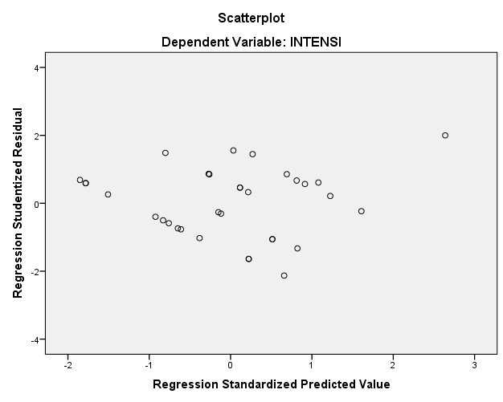
Sumber: Data primer yang diolah

Gambar 3.3
Hasil Uji Normalitas
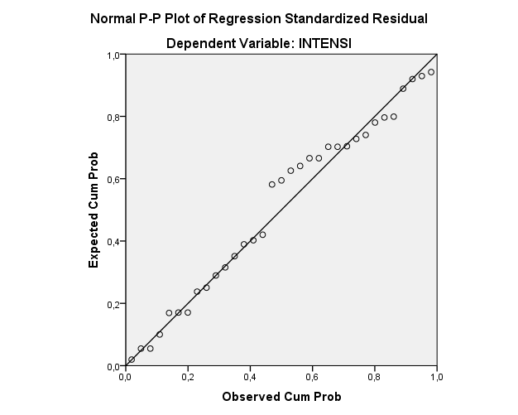
- Hasil Uji Hipotesis

Tabel 4.1
Hasil Uji Koefisien Determinasi (R²) variabel Y, X₁, X₂ dan X₃

Model Summary
Model | R | R Square | Adjusted R Square | Std. Error of the Estimate
1 | ,753ª | ,568 | ,523 | 1,02201
a. Predictors: (Constant), PERSEPSIAN, SIKAP, NORMA

Tabel 4.2
Hasil Uji Statistik F Variabel Y, X₁, X₂ dan X₃
ANOVAª
Model |  | Sum of Squares | Df | Mean Square | F | Sig.
1 | Regression | 39,770 | 3 | 13,257 | 12,692 | ,000^{b}
 | Residual | 30,291 | 29 | 1,045
 | Total | 70,061 | 32
a. Dependent Variable: INTENSI
b. Predictors: (Constant), Persepsian, SIKAP, NORMA
Sumber: Data primer yang diolah

Tabel 4.3
Hasil Uji Statistik t Variabel Y, X₁, X₂ dan X₃
Coefficientsª
Model |  | Unstandardized Coefficients |  | Standardized Coefficients | T | Sig.
 |  | B | Std. Error | Beta
1 | (Constant) | 2,104 | ,645 |  | 3,263 | ,003
 | SIKAP | ,255 | ,112 | ,486 | 2,283 | ,030
 | NORMA | ,186 | ,100 | ,409 | 1,868 | ,072
 | PERSEPSIAN | -,088 | ,039 | -,313 | -2,228 | ,034
a. Dependent Variable: INTENSI
Sumber: Data primer yang diolah

Tabel 4.4
Hasil Uji keofisien Determinasi (R₂) Variabel X₁, X₄, X₁X₄ dan Y
Model Summary
Model | R | R Square | Adjusted R Square | Std. Error of the Estimate
1 | ,726ª | ,528 | ,479 | 1,06833
a. Predictors: (Constant), MODERASI, SQ, SIKAP
Sumber: Data primer yang diolah

Tabel 4.5
Hasil Uji keofisien Determinasi (R2) Variabel X₁, X₄, X₁X₄ dan Y

ANOVAª
Model |  | Sum of Squares |  |  | Df | Mean Square |  | F | Sig.
1 | Regression |  | 36,962 | 3 |  | 12,321 | 10,795 |  |  | ,000^{b}
 | Residual |  | 33,099 | 29 |  | 1,141
 | Total |  | 70,061 | 32
a. Dependent Variable: INTENSI
b. Predictors: (Constant), MODERASI, SQ, SIKAP
Sumber: Data primer yang diolah

Tabel 4.6
Hasil Uji Statistik T Variabel X₁, X₄, X₁X₄ dan Y

Coefficientsª
Model |  | Unstandardized Coefficients |  |  | Standardized Coefficients | T | Sig.
 |  | B |  | Std. Error | Beta
1 | (Constant) |  | 13,094 | 6,227 |  | 2,103 | ,044
 | SIKAP |  | -1,034 | ,721 | -1,970 | -1,433 | ,163
 | SQ |  | -,218 | ,116 | -,779 | -1,883 | ,070
 | MODERASI |  | ,026 | ,014 | 2,600 | 1,935 | ,063
a. Dependent Variable: INTENSI
Sumber: Data primer yang diolah
Tabel 4.7
Hasil Uji keofisien Determinasi (R₂) Variabel X₂, X₄, X₂X₄ dan Y
Model Summary
Model | R | R Square | Adjusted R Square | Std. Error of the Estimate
1 | ,711ª | ,505 | ,454 | 1,09320
a. Predictors: (Constant), MODERASI, SQ, NORMA
Sumber: Data primer yang diolah

Tabel 4.8
Hasil Uji keofisien Determinasi (R₂) Variabel X₂, X₄, X₂X₄ dan Y

ANOVAª
Model |  | Sum of Squares | Df | Mean Square | F | Sig.
1 | Regression | 35,403 | 3 | 11,801 | 9,874 | ,000^{b}
 | Residual | 34,658 | 29 | 1,195
 | Total | 70,061 | 32
a. Dependent Variable: INTENSI
b. Predictors: (Constant), MODERASI, SQ, NORMA
Sumber: Data primer yang diolah

Tabel 4.9
Hasil Uji Statistik T Variabel X₂, X₄, X₂X₄ dan Y
Coefficientsª
Model |  |  | Unstandardized Coefficients |  | Standardized Coefficients | T | Sig.
 |  |  | B | Std. Error | Beta
1 | (Constant) | 16,861 |  | 7,006 |  | 2,407 | ,023
 | NORMA | -1,444 |  | ,840 | -3,176 | -1,719 | ,096
 | SQ | -,274 |  | ,128 | -,978 | -2,134 | ,041
 | MODERASI | ,032 |  | ,015 | 3,793 | 2,073 | ,047
a. Dependent Variable: INTENSI
Sumber: Data primer yang diolah

Tabel 4. 10
Hasil Uji keofisien Determinasi (R₂) Variabel X₃, X₄, X₃X₄ dan Y
Model Summary
Model | R | R Square | Adjusted R Square | Std. Error of the Estimate
1 | ,528ª | ,278 | ,204 | 1,32026
a. Predictors: (Constant), MODERASI, SQ, PERSEPSIAN
Sumber: Data primer yang diolah
Tabel 4.11
Hasil Uji keofisien Determinasi (R₂) Variabel X₃, X₄, X₃X₄ dan Y
ANOVAª
Model |  | Sum of Squares | Df | Mean Square | F | Sig.
1 | Regression | 19,511 | 3 | 6,504 | 3,731 | ,022^{b}
 | Residual | 50,549 | 29 | 1,743
 | Total | 70,061 | 32
a. Dependent Variable: INTENSI
b. Predictors: (Constant), MODERASI, SQ, PERSEPSIAN
Sumber: Data primer yang diolah

Tabel 4.12
Hasil Uji Statistik T Variabel X₂, X₄, X₂X₄ dan Y
Coefficientsª
Model |  |  | Unstandardized Coefficients |  |  |  | Standardized Coefficients |  | T | Sig.
 |  |  | B |  | Std. Error |  | Beta
1 | (Constant) | 27,761 |  | 7,123 |  |  |  | 3,897 |  | ,001
 | PERSEPSIAN | -1,581 |  | ,506 |  | -5,440 |  | -3,125 |  | ,004
 | SQ | -,431 |  | ,130 |  | -1,539 |  | -3,322 |  | ,002
 | MODERASI | ,029 |  | ,009 |  | 5,476 |  | 3,159 |  | ,004
a. Dependent Variable: INTENSI
Sumber: Data primer yang diolah

